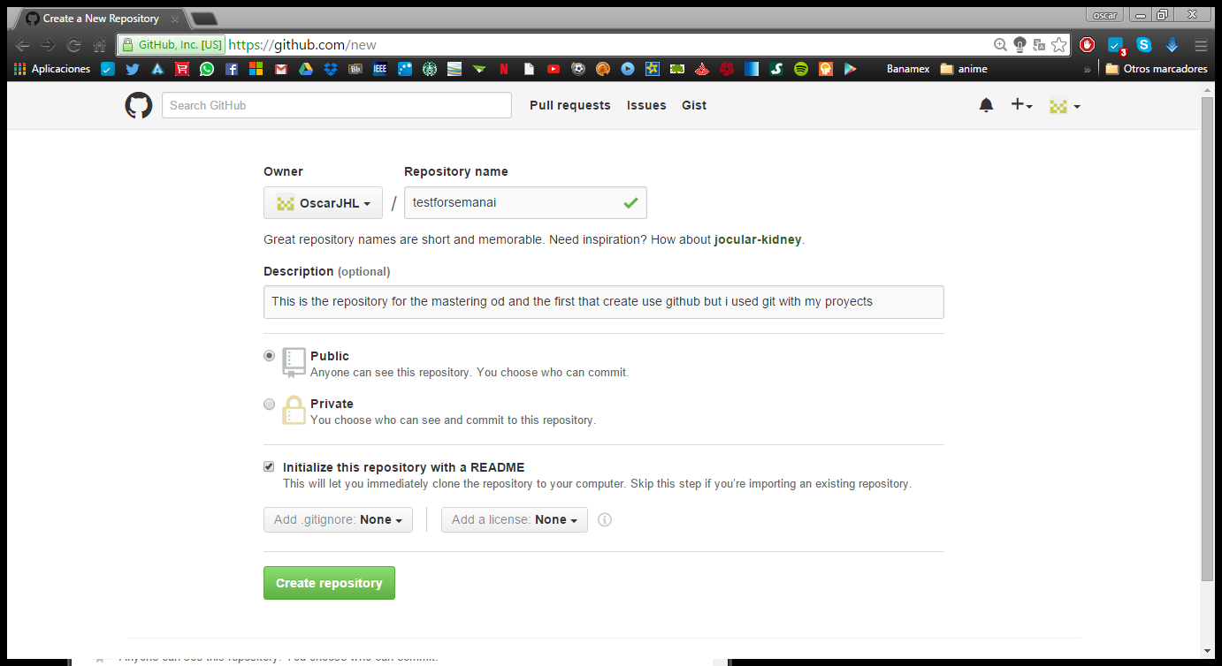

I create a count in github and start create a new repository in the page of github

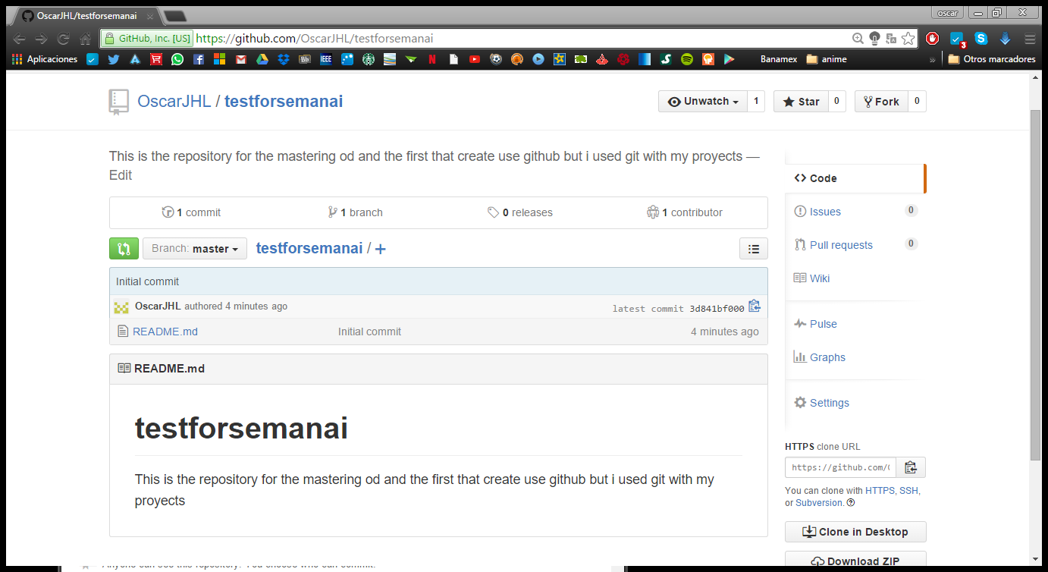

Creating the repository in the web

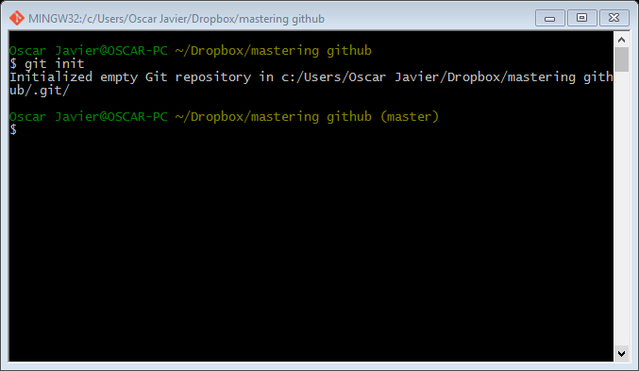

Create a local repository on your computer.

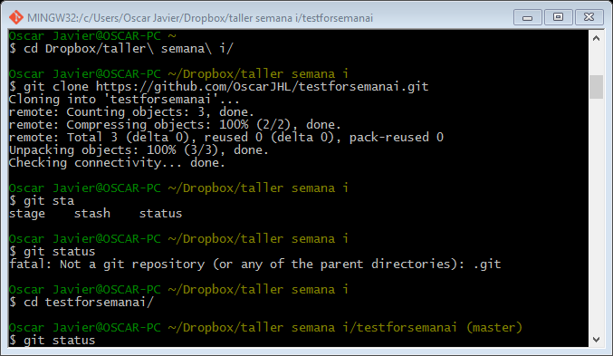

Clone a repository from GitHub to your computer.

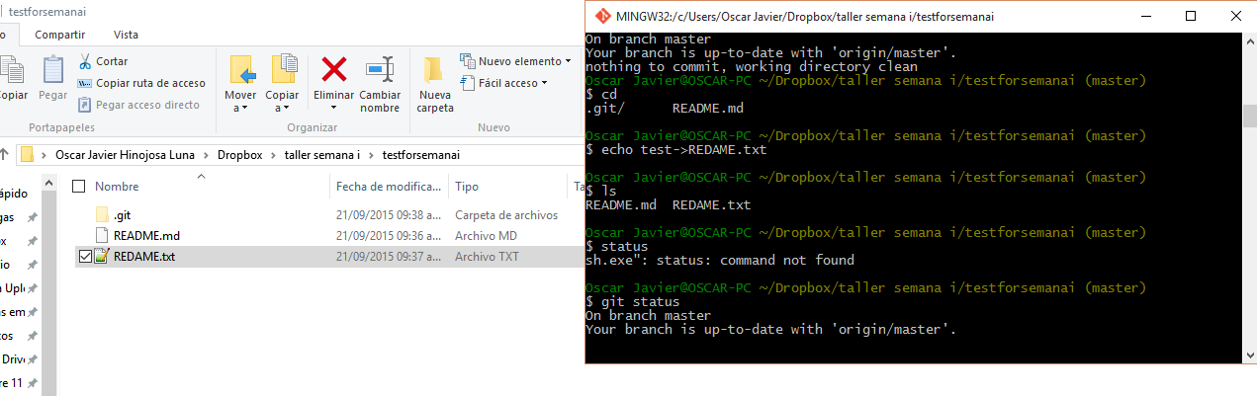

I add a file to my local repository with command echo.

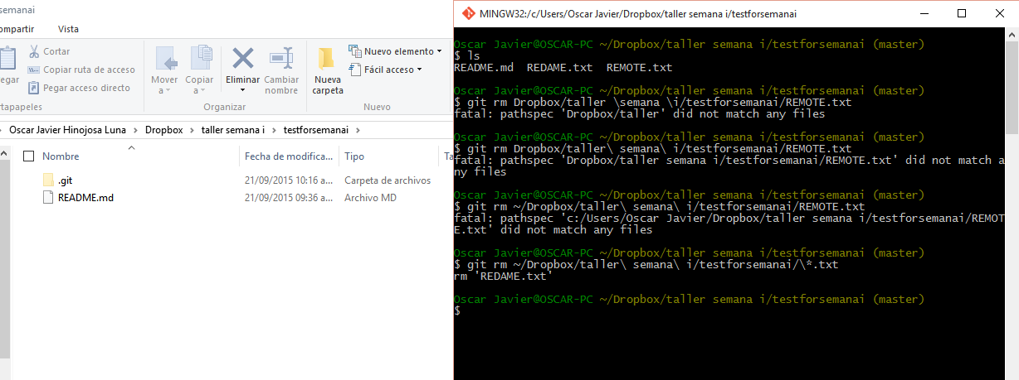

Remove a file from your local repository.

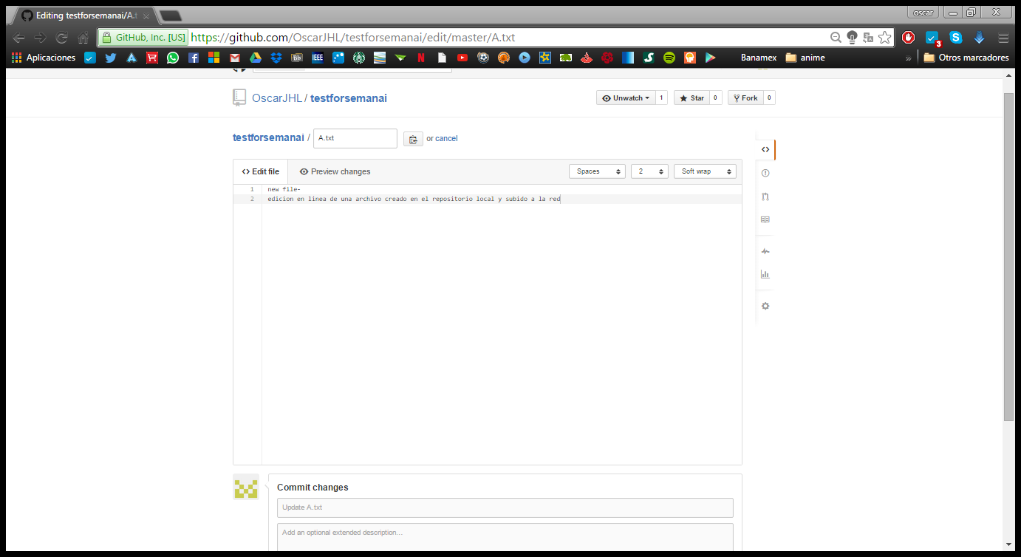

I am editing a file via the GitHub web interface this file was created in the local repository.

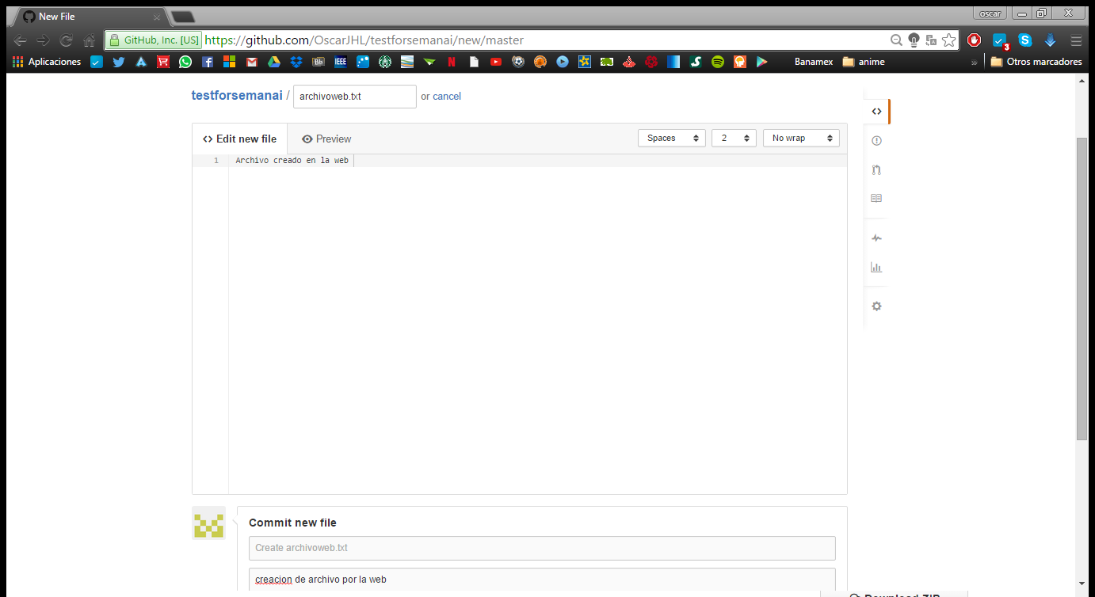

Add a file via the GitHub web interface.

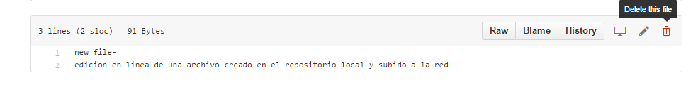

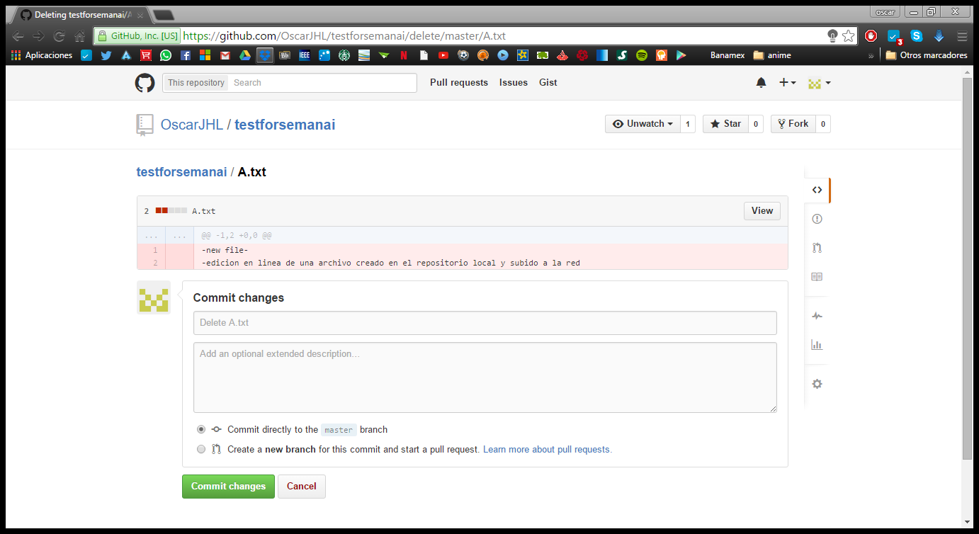

Delete a file via the GitHub web interface.

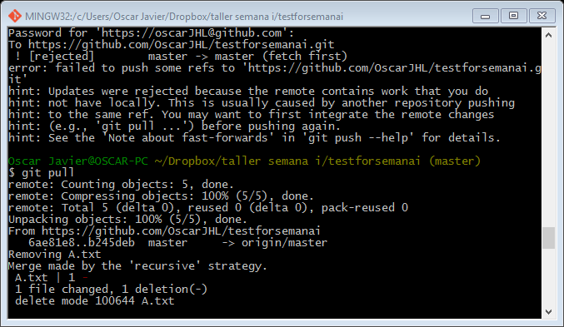Pull changes from GitHub to your local repository.

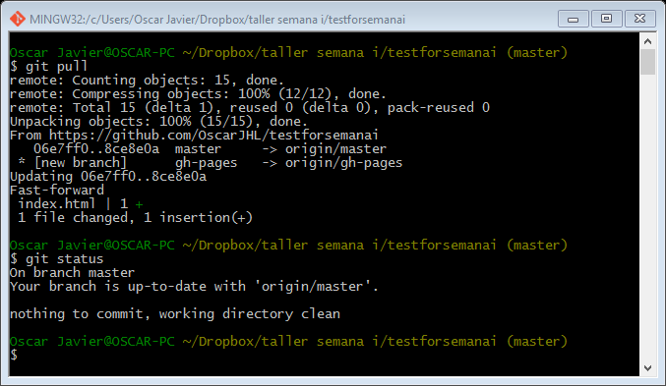

Check status of your local repository. What are the possible states?

2 stage tracked or untracked when tracked is that are in the last snapshot of the repository and untracked that not was in the last snapshot.

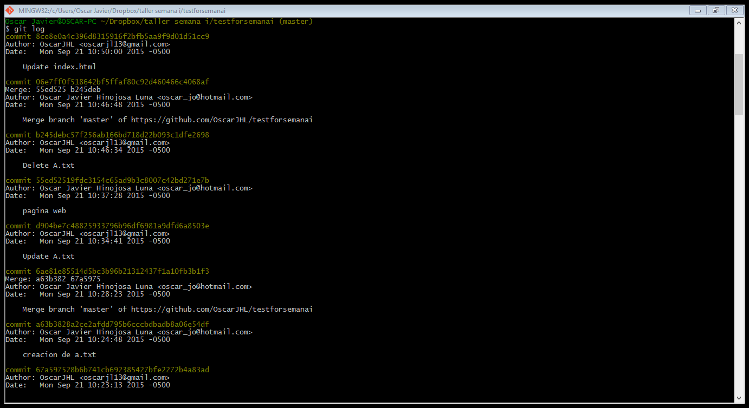

How to view the history or log of your repository. Why is this useful?

Because with the log; you can check how go the project and if you need to return a previous version you can check what do you have working and what do you lose with this.

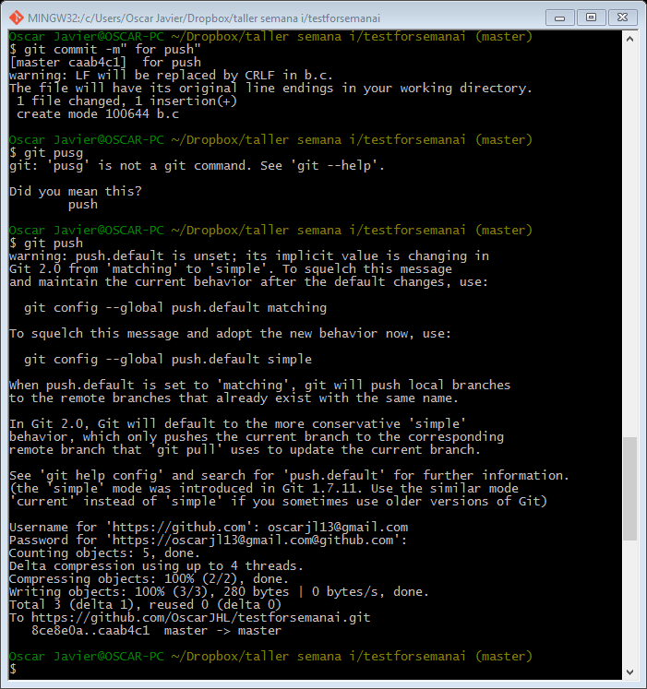

Push changes to GitHub from your local repository.

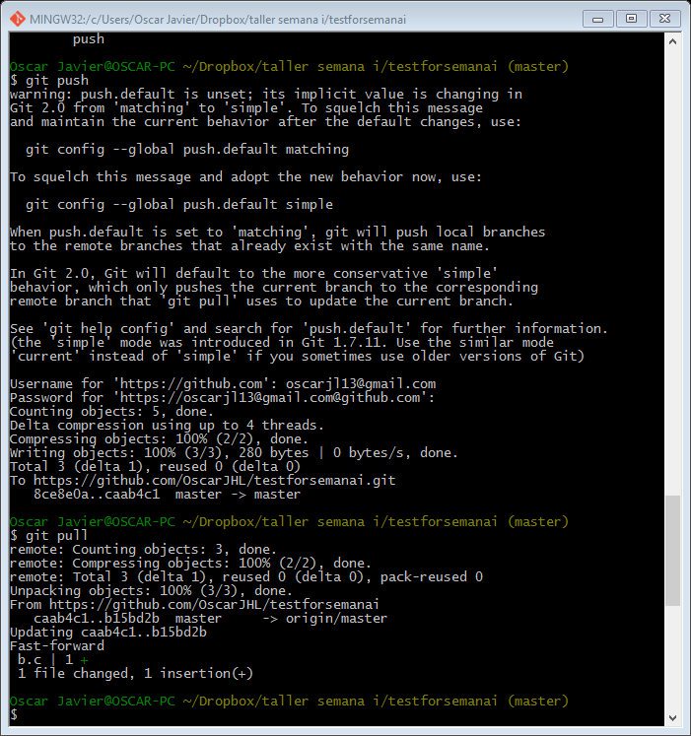

Pull changes from GitHub to your local repository.

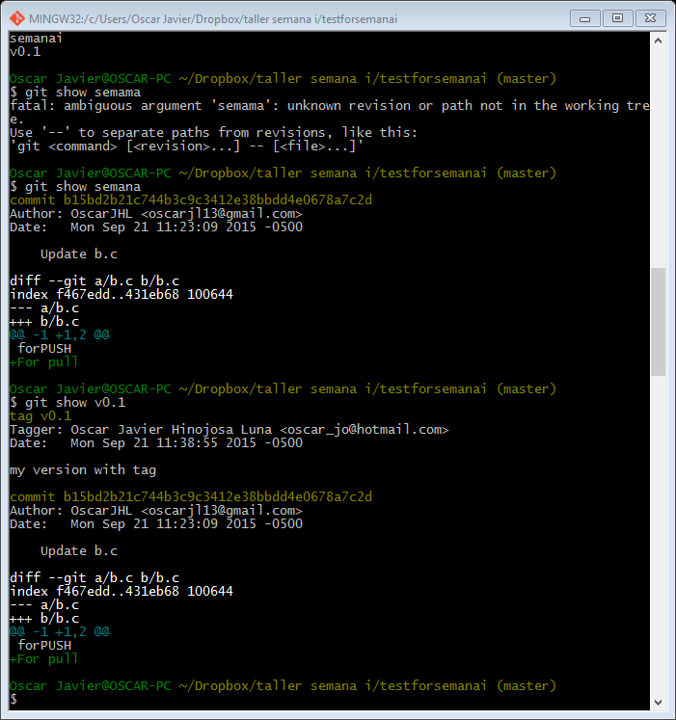

Create an use Tags at the local repository leve.

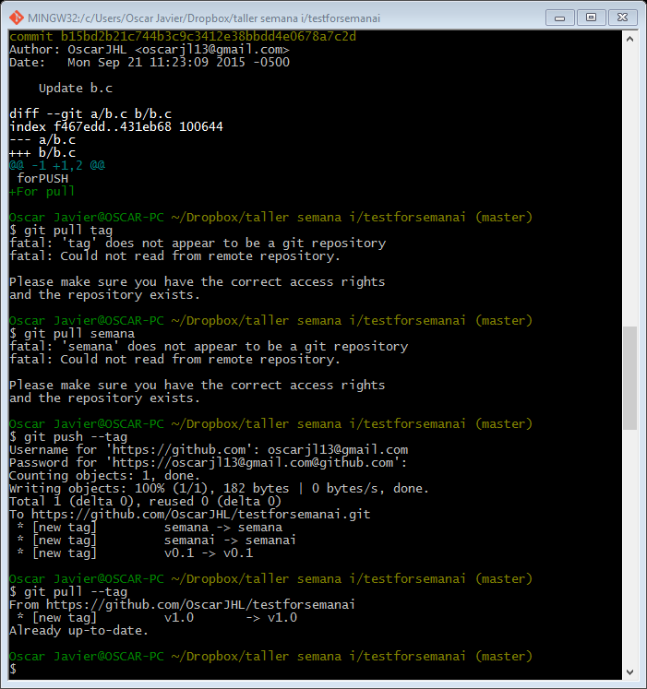

Push and  pull tags to the remote (GitHub) repository.

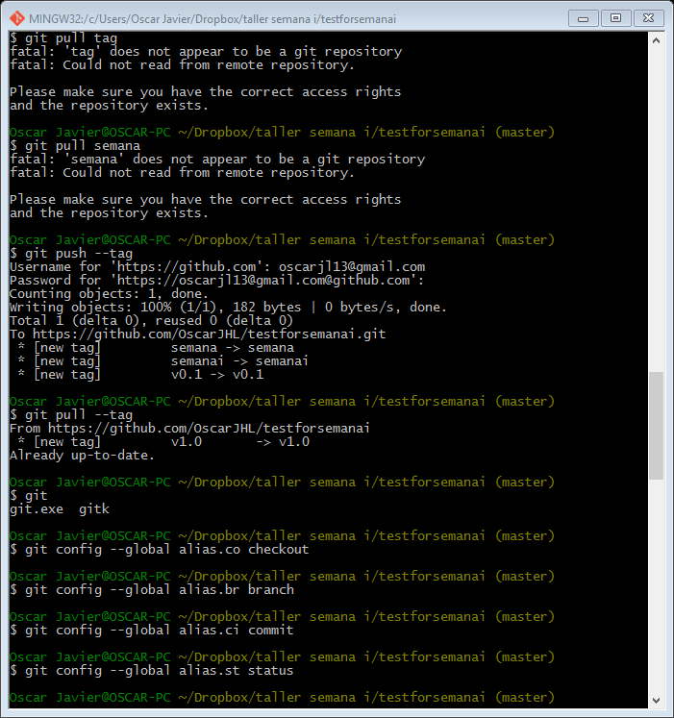

Setup git aliases for your local configuration.

Get git to ignore certain files. Why do we want to do this? Because for example in some program language create some files that change every time that you compile and this files that not necessary put in the repository.

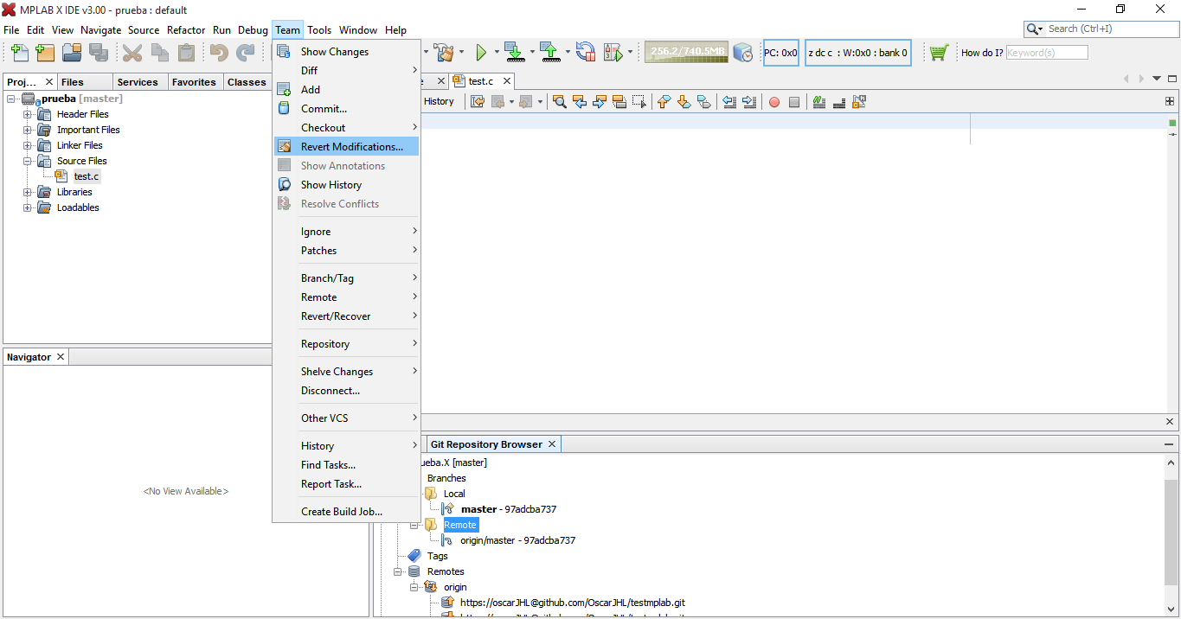

1. Check out how Git is supported in your favourite editor. Does it just show information or does it have support for Git commands?

The editor have include a GUI for management GIT and you can use all the command of git and with the remote option I connect my project with GitHub

DiffMerge

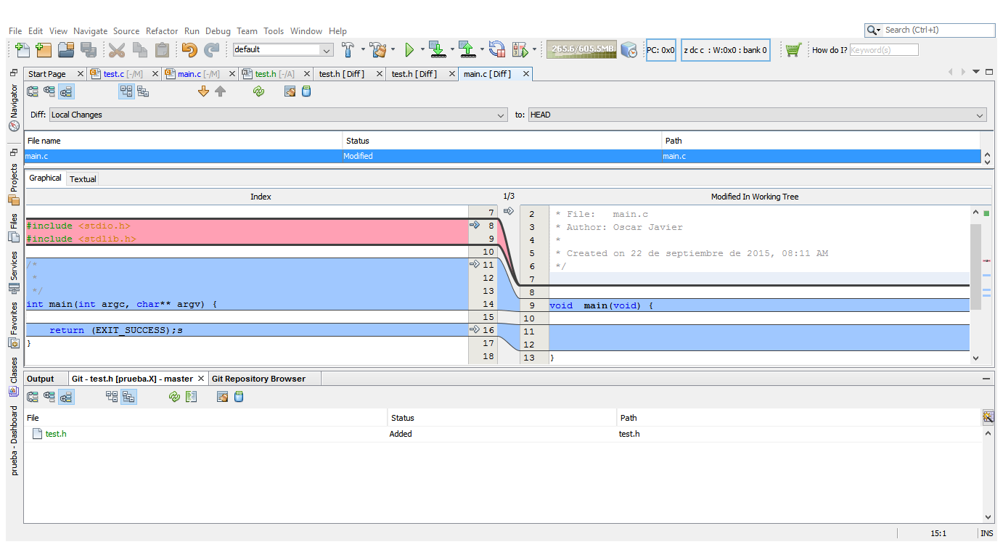

I use this idle based in netbeans to create and design programs for microcontroller the branch microchip and this program have tools to see the difference between the actual program and the HEAD and also with other versions .

Branching

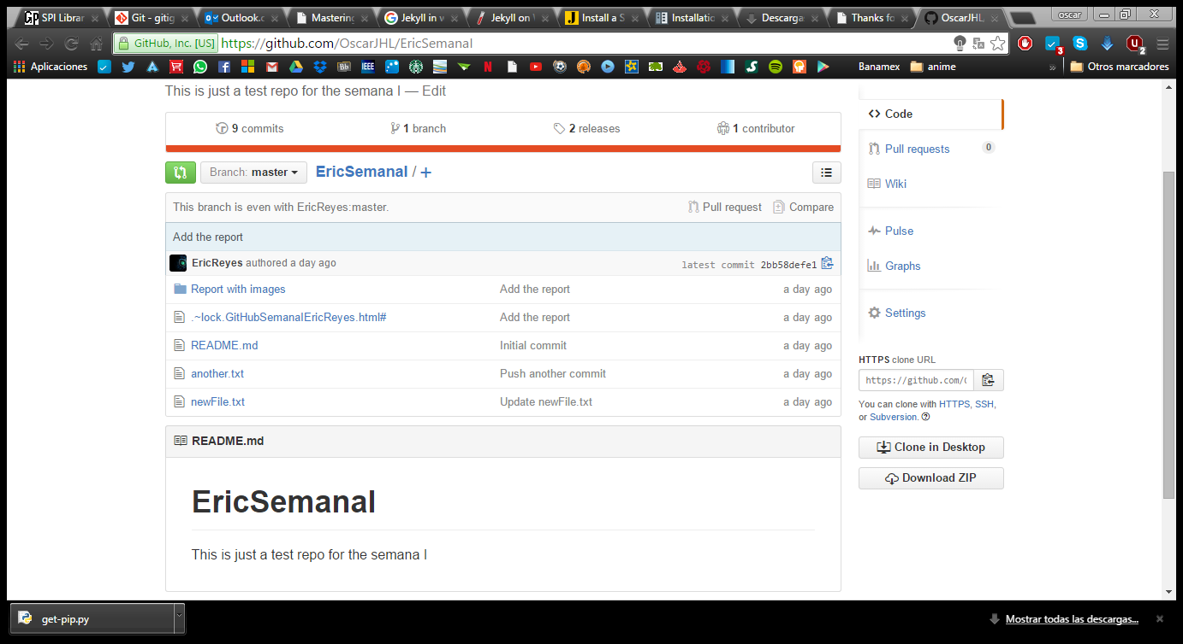

I fork the Repository of my parther.

1. Work with a partner to fork their repository via GitHub. Now you can modify and work with your own copy of that repository. You can fork anything on GitHub, that is what the community is about!

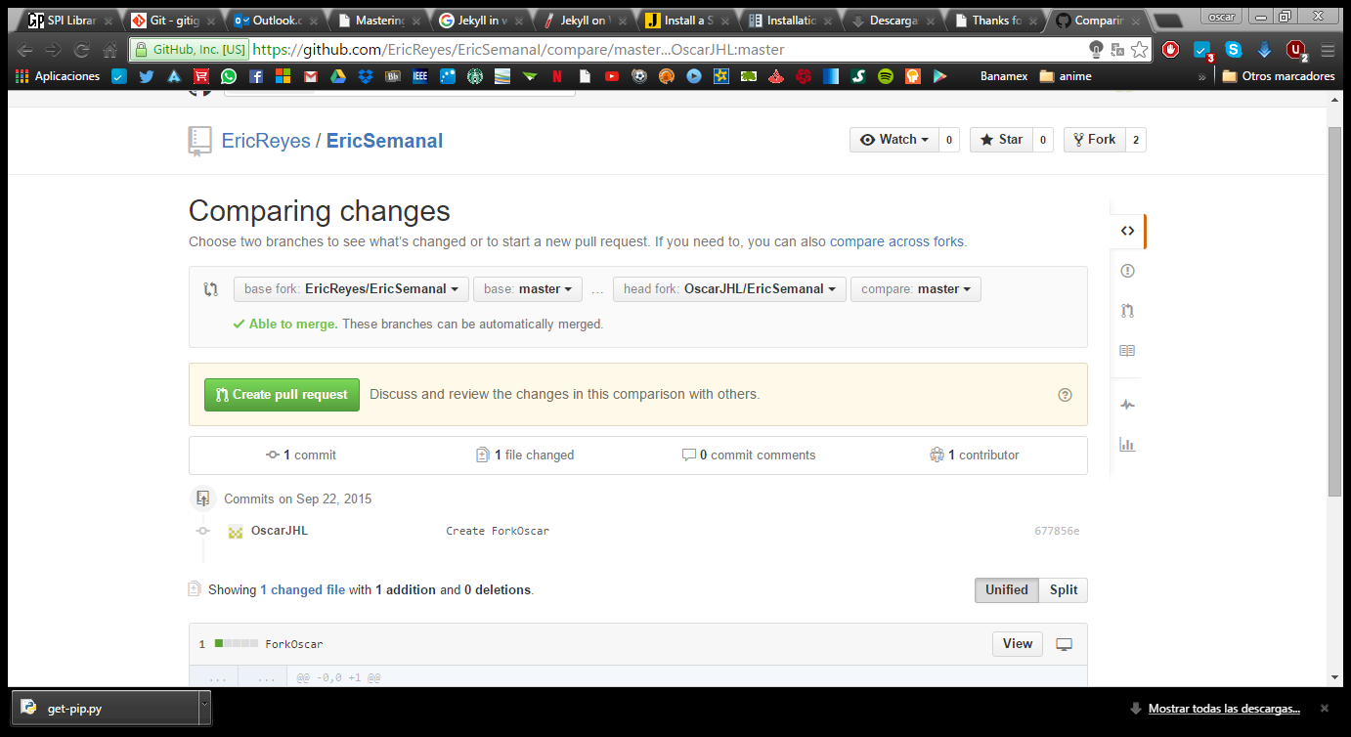

Creating a request for pull request for the repository.

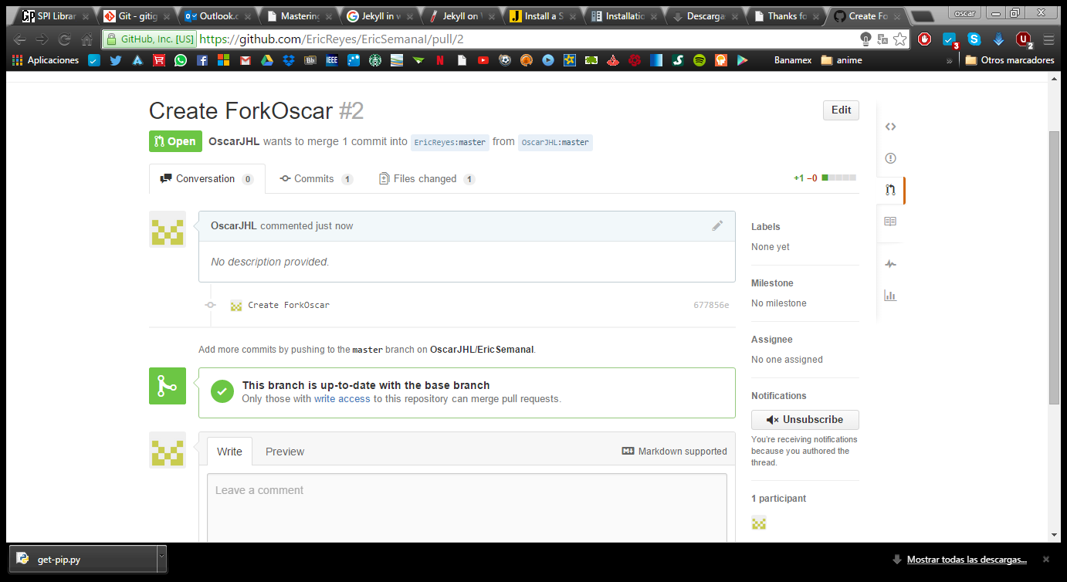

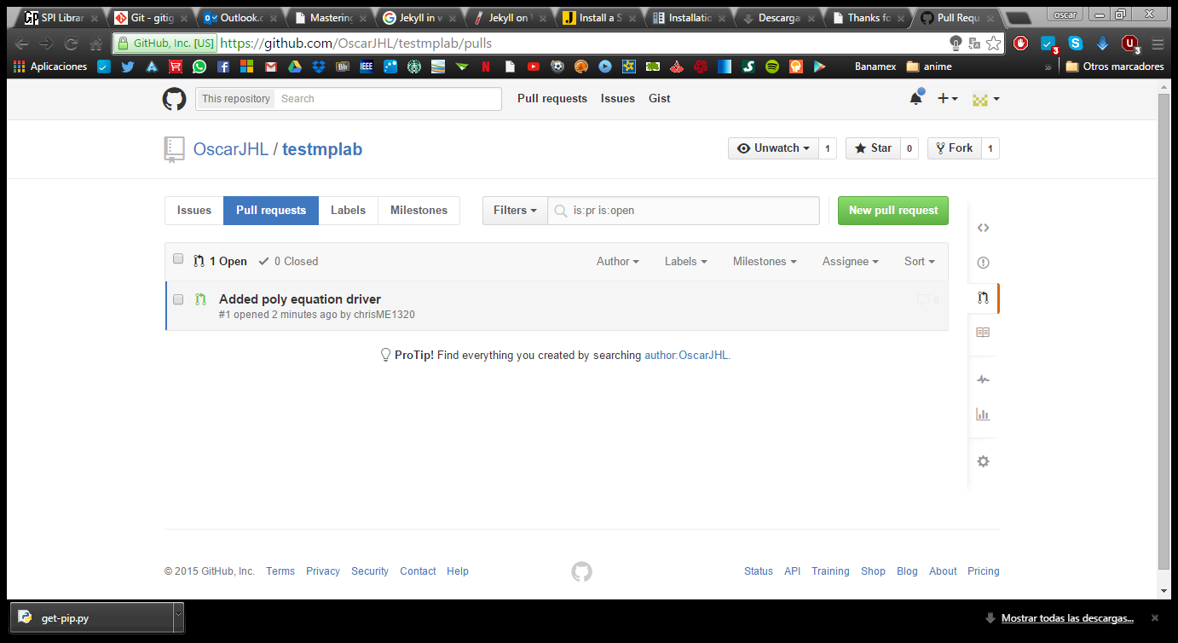

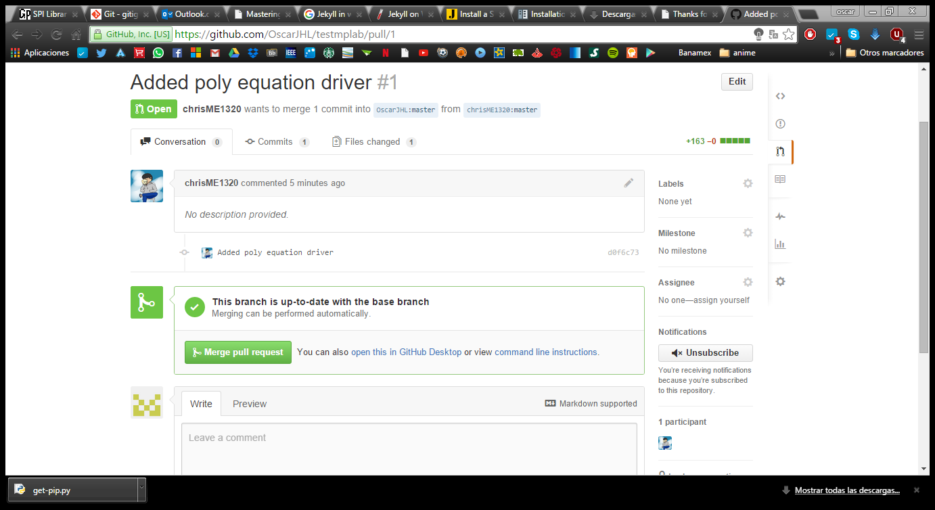

I received the request to pull from other parent that fork and pull to my repository.

1. Now since you are working with a partner you can organize to create a pull request so that your modifications on your forked repository go back to her main repository that you forked from.

GitHub Pages

1. You can get free hosting with [GitHub Pages](https://pages.github.com/). Set up your own page with this. 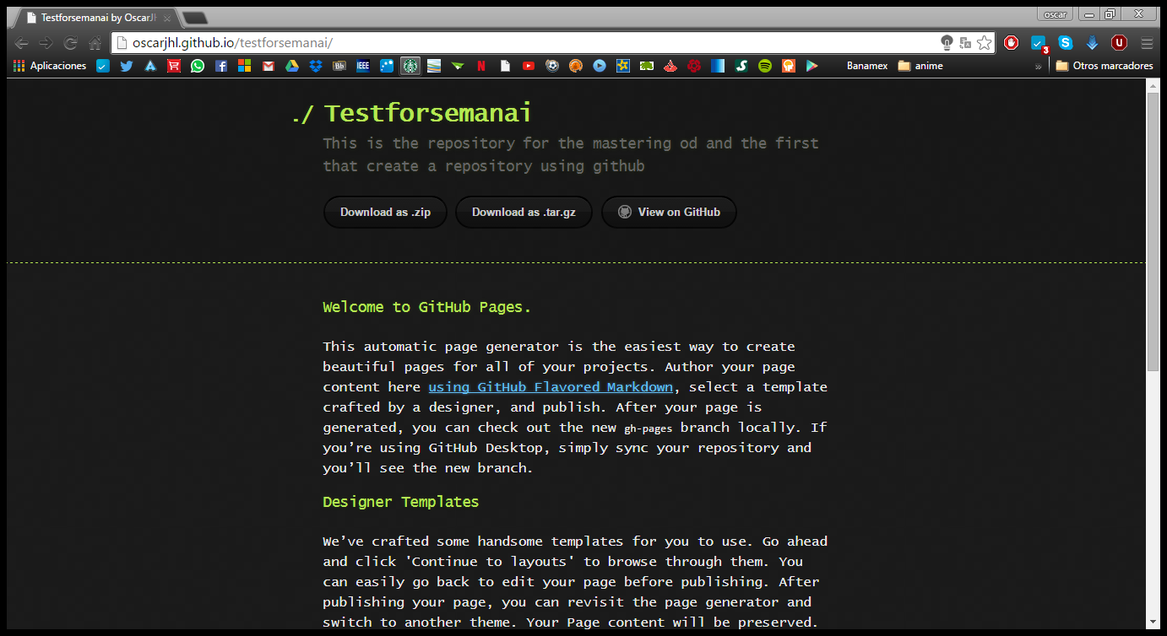
2. To get a full score on this portion use a static website generator like Jekyll, OctoPress, Hexo or any other choice to “build” a site using that publishes to GitHub. Another option is to use GitHub to develop your site but synchronize the built site to some other location.